Project Synopsis

on

**WASRUK**

Submitted as a part of course curriculum for

**Bachelor of Technology**

in

**Computer Science**

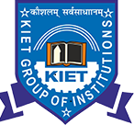

**Submitted by**

Satyendra Singh (2100290120150)

Sneha (2100290120163)

Satyam Srivastava (2100290120149)

**Under the Supervision of**

Pradeep Tyagi

Prof. Computer Science

**KIET Group of Institutions, Ghaziabad**

**Department of Computer Science**

**Dr. A.P.J. Abdul Kalam Technical University**

**2022-2023**

**ACKNOWLEDGEMENT**

It gives us a great sense of pleasure to present the synopsis of the B.Tech Mini Project undertaken during B.Tech. Third Year. We owe a special debt of gratitude to PRADEEP TYAGI PROF. COMPUTER SCIENCE, Department of Computer Science, KIET Group of Institutions, Delhi- NCR, Ghaziabad, for his constant support and guidance throughout the course of our work. His sincerity, thoroughness and perseverance have been a constant source of inspiration for us. It is only his cognizant efforts that our endeavours have seen the light of the day.

We also take the opportunity to acknowledge the contribution of Dr. Ajay Kumar Shrivastava, Head of the Department of Computer Science, KIET Group of Institutions, Delhi- NCR, Ghaziabad, for his full support and assistance during the development of the project. We also do not like to miss the opportunity to acknowledge the contribution of all the faculty members of the department for their kind assistance and cooperation during the development of our project.

Last but not the least, we acknowledge our friends for their contribution to the completion of the project.

Signature: Guide Name & Signature

Student’s Name:

Roll No:

**ABSTRACT**

WASRUK, an acronym for Waste Segregation and Recycling for a Sustainable Environment, is a comprehensive project aimed at addressing the pressing issue of waste management and landfill reduction. Our project focuses on the collection and segregation of waste from both domestic regions and organizations, leveraging a multifaceted approach to minimize the burden on landfills and promote environmental sustainability.

The project encompasses three key components: a user-friendly front-end web interface for seamless interaction with our platform, a robust back-end system for efficient waste management and tracking, and the integration of machine learning algorithms to enhance waste segregation accuracy and efficiency.

One of the innovative features of WASRUK is the introduction of a unique incentive system in the form of W-coins. Users who actively participate in waste segregation and recycling efforts earn W-coins, which can be redeemed for various benefits such as mobile recharges or online shopping vouchers. This incentivization mechanism not only encourages individuals to engage in environmentally responsible behaviors but also fosters a sense of community involvement in sustainability initiatives.

Through WASRUK, we aim to establish an ecosystem where waste management is transformed into a rewarding experience, driving positive environmental impact while empowering individuals to contribute towards a cleaner and greener future. Join us in our mission to revolutionize waste management practices and create a sustainable tomorrow for generation to come.

**TABLE OF CONTENTS**

|  |  |
| --- | --- |
|  | Page No. |
| TITLE PAGE .................................................................................................................... | i |
| ACKNOWLEDGEMENT.................................................................................................. | ii |
| ABSTRACT...................................................................................................................... | iii |

|  |  |
| --- | --- |
| CHAPTER 1 INTRODUCTION | 1-n |
|  |  |
|  |  |
| 1.1.          Introduction ……………………................................................... | 1 |
| 1.2 Problem Statement.……………………....................................... |  |
| 1.2.          Objective………………………………………………………… | 2 |
| 1.3.          Scope……………………………………………………………. | 3 |
| CHAPTER 2 PROPOSED METHODOLOGY …………………………………........ | 8-m |
| 2.1 Flowchart |  |
| 2.2 Algorithm Proposed | 10 |
| CHAPTER 3 TECHNOLOGY USED ………..………………………..………………. | 12 |
| CHAPTER 4 ER DIAGRAM .......................................................................................... |  |
| CHAPTER 5 CONCLUSION …....................................................................................... |  |
| REFERENCES….............................................................................................................. |  |

**INTRODUCTION:**

WasRuk is formed by the combination of two words, **Was**te and T**ruck** whose moto is to transport the waste to the right place and does not reduce the value of waste by dumping it.

When waste is dumped in the dumping yard its value reduces as the time passes and we can’t use that waste in the future for making something useful.

WasRuk collects the segregated waste from the households and that segregated waste is again segregated into multiple categories and directly sold to the recycling industry and to the biogas plant while we make profit from that waste and try to return some of part of the revenue to each household so that they stay motivated to help us in the cause.

The moto of WasRuk is that people understand the value of waste and build a habit to segregate it into multiple categories and for their segregation WasRuk provide the certificate of appreciation from government of India and also try to return the value of their waste by our website and app.

**PROBLEM STATEMENT:**

A report reveals that the Indian government imports 45 million tons of garbage every year from different countries. Not only this, but this number also increases by 4 percent every year. On the other hand, INDIA produces 65 million tons of waste every year. This waste that accumulates in such a huge quantity is of many types. One is recyclable i.e., plastic the other type being the non-biodegradable waste, and at last bio-medical such as sanitary and hazardous waste. All this waste is being dumped on free land if this continues then in the coming years every city will several numbers of these "WASTE MOUNTAIN".

In a country like India, the biggest problem is Waste Management. India is fifth – largest economy by nominal GDP in the world but still lags in waste management. India is importing around 90000 tons of scrap from other countries despite having its own very huge collection of waste that’s a big problem. The daily waste production in India ranges from about 1,00,000 metric tons. A survey conducted by a verified source states that if this amount of waste production continues like that without its proper management, then each city in India will have its own Heap of Garbage. The main problem that comes across recycling waste is the segregation of the different kinds of waste from such a huge collection. This could be solved at the primary level let us say from the houses if the people get aware of the kinds of waste and segregation is done at the time of collection of waste then this issue can be solved.

As per the data given by INDIAN AGRO & RECYCLED PAPER MILLS ASSOCIATION India imports 60% of its total required raw paper from outside India. Our proposed solution of segregation of waste will help India in making itself ATMANIRBHAR in the field of Paper management.

|  |  |
| --- | --- |
| **OBJECTIVES:**  As per the data given by **INDIAN AGRO & RECYCLED PAPER MILLS ASSOCIATION** India imports 60% of its total required raw paper from outside India.  A report reveals that the Indian government imports 45 million tons of garbage every year from different countries. Not only this, but this number also increases by 4 percent every year.  Javadekar pointed out that 43 millions tonnes of solid waste are collected annually , out of which 11.9 million (22-28%) are treated and 31 million (72-78%) are dumped at landfill sites . If garbage is dumped at the current rate without any treatment 1,240 hectares of land will be required in the landfill area per year. |  |
|  |  |
|  |  |

**FUTURE SCOPE:**

**Expansion of Services**: In the future, WASRUK can explore opportunities to expand its services beyond waste collection and recycling. This may include initiatives such as electronic waste management, composting, and the implementation of sustainable packaging solutions.

**Enhanced Machine Learning Algorithms**: Continual refinement and enhancement of machine learning algorithms can improve the accuracy of waste segregation and classification. WASRUK can invest in research and development to further optimize these algorithms, leading to more effective waste management practices.

**Partnerships and Collaborations**: Collaborating with governmental agencies, non-profit organizations, and private enterprises can broaden the impact of WASRUK's initiatives. Establishing partnerships can facilitate access to resources, expertise, and funding, enabling WASRUK to scale its operations and reach a larger audience.

**Data Analytics for Decision Making**: Utilizing advanced data analytics techniques, WASRUK can derive actionable insights from the vast amounts of data collected during waste management operations. This data-driven approach can inform strategic decision-making, optimize resource allocation, and drive continuous improvement in waste management processes.

By embracing these future scope initiatives, WASRUK can continue to lead the way in sustainable waste management practices, making significant strides towards a cleaner, healthier, and more environmentally conscious society.

**METHODOLOGY:**

We are revolutionizing the field of waste management by changing the behavior and mindset of people towards waste. It will be done by making them aware that they can monetize their waste.

We will ask the people to segregate the waste at the source into multiple categories and in return, we will provide them with rewards like gift vouchers, coupons, and cashback through our website or app.

**We will work in the following steps**:

* We will allure the public by giving them rewards for segregating the waste right from their homes.
* We will take the segregated waste from people, recycle it to make market ready products.
* We will sell this market ready product in the relevant industry which will be our main source of return.
* The public will receive **Wcoins** for every delivery of garbage which can be redeemed later on in form of awards, gifts and other exciting prizes .
* Our this solution will help the country in solving its garbage handling problem.
* We will appeal the public to segregate the waste into various subcategories such as : Plastic waste, Paper waste, E- waste and organic waste, for each transaction the public will be awarded with Wcoins in their E- wallets which can be redeemed later on.
* We will create a family ranking system based on their contribution towards segregation. Top families will be rewarded and appreciated by the government.
* FLOWCHART: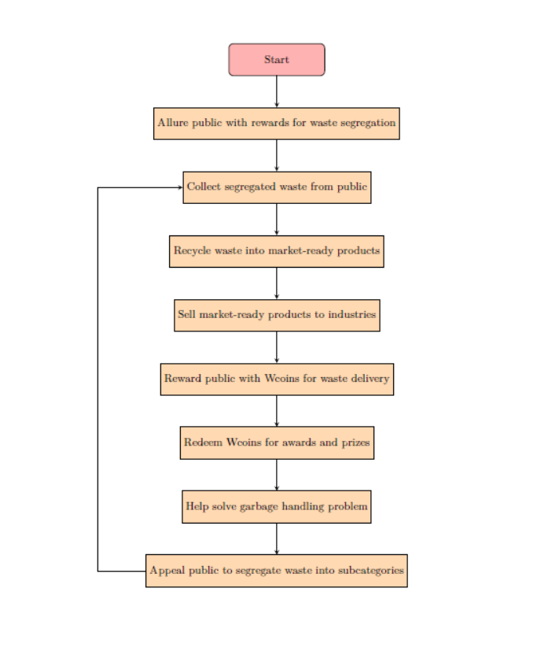
* ALGORITHM:

1. Start
2. Allure the public by offering rewards for segregating waste at their homes.
3. Collect segregated waste from the public.
4. Check if the collected waste is contaminated:
   1. If contaminated:
   2. Discard contaminated waste and resume collection process.
   3. Else:
   4. Proceed to recycling.
5. Recycle the waste to produce market-ready products.
6. Sell the market-ready products to relevant industries.
7. Reward the public with Wcoins for every delivery of segregated waste.
8. Allow the public to redeem Wcoins for awards, gifts, and prizes.
9. Contribute to solving the garbage handling problem.
10. Appeal to the public to segregate waste into subcategories such as Plastic waste, Paper waste, E-waste, and Organic waste.
11. End

**TECH STCK USED:**

FRONT-END HTML, CSS, JAVASCRIPT, REACT

FRAMEWORK/LIBRARY FONT AWESOME, GOOGLE FONT, BOOTSTRAP

BACKEND PYTHON, DJANGO, ML(PYTHON LIBRARIES)

TEXT EDITOR VISUAL STUDIO CODE

DATABASE SQLITE3

**CONCLUSION:**

In conclusion, WASRUK represents a groundbreaking initiative in the realm of waste management and environmental conservation. Through the integration of advanced technology, user-friendly interfaces, and innovative incentive mechanisms, our project endeavors to revolutionize the way waste is handled, thereby mitigating the adverse impacts of excessive landfill accumulation. By fostering active participation from individuals and organizations alike, WASRUK not only promotes sustainable waste management practices but also cultivates a collective consciousness towards environmental stewardship. As we strive towards a cleaner and greener future, we invite stakeholders to join hands in our mission to create a more sustainable world for generations to come. Together, let us embrace the transformative power of WASRUK and pave the way towards a brighter tomorrow.

**REFERENCES:**

1. Indian Agro & Recycled Paper Mills Association. "Waste Management Statistics Report." Version 1.0. January 2024.

Government of India. "National Waste Management Policy." Version 2.0. December 2023.